SIMATS ENGINEERING
ASSESSMENT TOOL 1

COURSE CODE: ITA0601 COURSE NAME: MACHINE LEARNING

COURSE OUTCOME COVERED

CO4: K- Nearest Neighbour Learning – Locally weighted Regression – Radial Bases Functions – Case Based Learning (BL 5)

Assessment Tool Weightage: 40%

QUESTIONS: 15 Total Marks:25

Annexure A

Coding Challenge

Code of Conduct:

I __S. Sri Sai Prasanna Durga (192424241) (Name / Reg No) certify that this submission is my original work and that I have adhered to the guidelines specified for this assessment.
I understand that any violation of academic integrity rules will result in disciplinary action.

Signature of the student: S. Sai Prasanna

Annexure A

Short Answer Test

1, Write a Python program to implement the K-Nearest Neighbour (KNN) algorithm for a small dataset. Use Euclidean distance to find nearest neighbors and classify a test instance. Allow the user to input the value of K and display predicted class labels with accuracy.

Aim:
To implement the K-Nearest Neighbour (KNN) classification algorithm using Python, calculate Euclidean distance between data points, classify a test instance based on the nearest neighbours, and evaluate the model using accuracy.
Algorithm:
- Create a small dataset containing features and class labels.
- Split the dataset into training and testing data.
- Accept the value of K from the user.
- Calculate the Euclidean distance between the test point and every training point.
- Select the K nearest data points.
- Count the class labels of the selected neighbours.
- Assign the class with the highest frequency to the test point.
- Compare predicted labels with actual labels.
- Calculate and display the classification accuracy.
Python Code:
import math
data = [
([1, 2], "A"),
([2, 3], "A"),
([3, 2], "A"),
([7, 8], "B"),
([8, 7], "B"),
([9, 8], "B")
]
test_data = [
([2, 2], "A"),
([8, 8], "B")
]
k = int(input("Enter K value: "))
correct = 0
for test_point, actual in test_data:
distances = []
for point, label in data:
distance = math.sqrt(
(point[0] - test_point[0]) ** 2 +
(point[1] - test_point[1]) ** 2
)
distances.append((distance, label))
distances.sort()
nearest = [label for distance, label in distances[:k]]
prediction = max(set(nearest), key=nearest.count)
print("Test Point:", test_point)
print("Actual Class:", actual)
print("Predicted Class:", prediction)
print()
if prediction == actual:
correct += 1
accuracy = (correct / len(test_data)) * 100
print("Accuracy:", accuracy, "%")

Output:
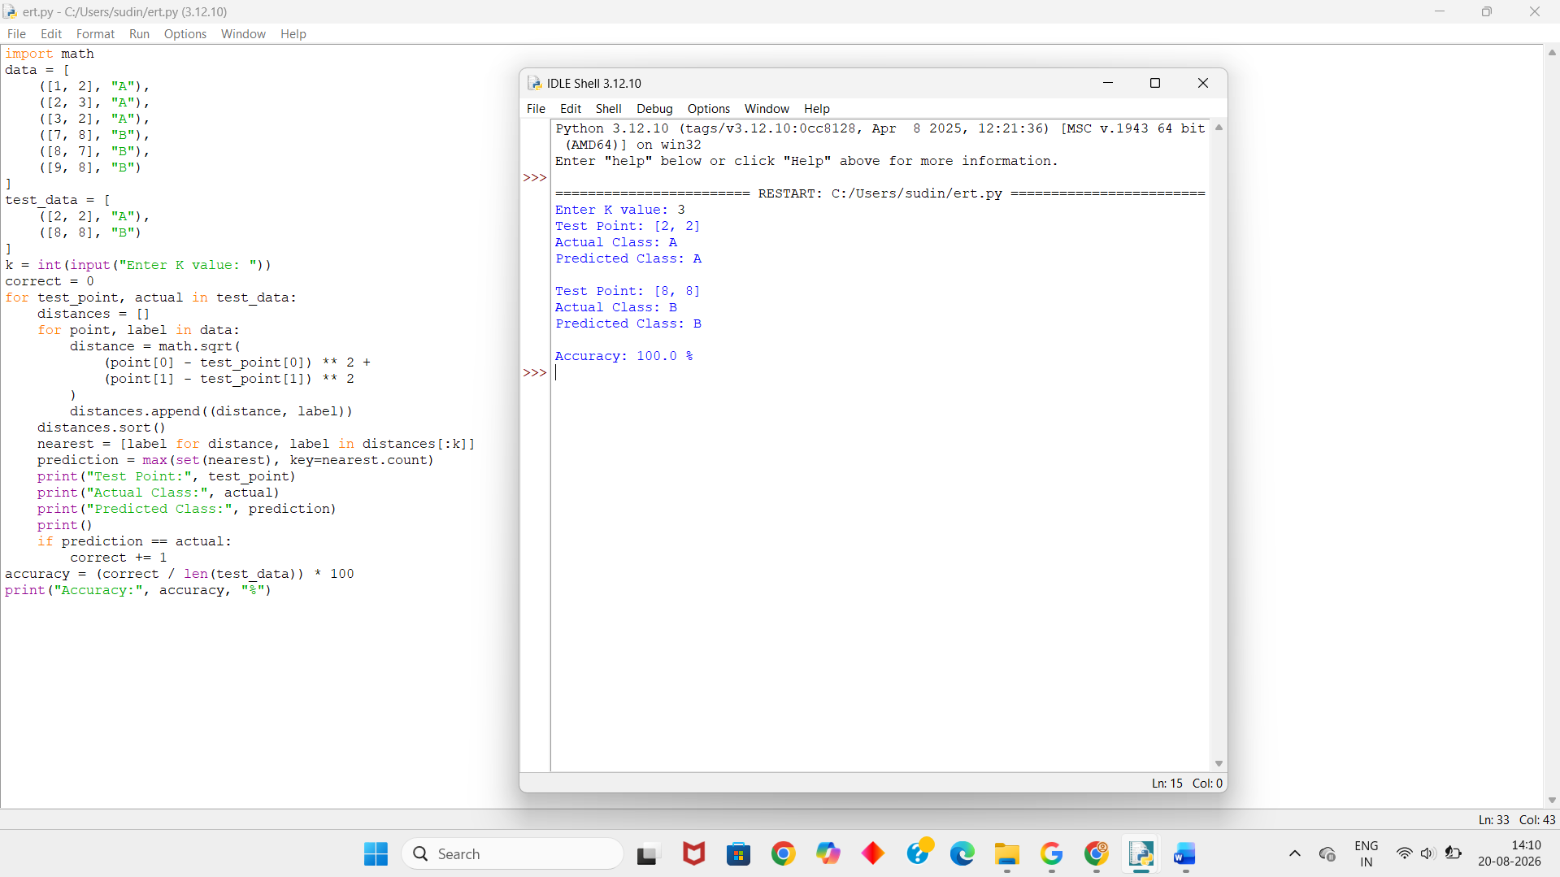

2. Develop a Python program to implement Locally Weighted Regression. Given a dataset, compute weights based on distance and predict output for a query point. Use a simple kernel function and compare predictions with standard linear regression for better understanding.

Aim:
To implement Locally Weighted Regression (LWR) using a Gaussian kernel and compare its prediction with standard Linear Regression.
Algorithm:
- Create a small dataset containing input and output values.
- Choose a query point.
- Calculate the distance between the query point and each data point.
- Calculate weights using a Gaussian kernel.
- Use the weights to calculate the locally weighted prediction.
- Calculate the prediction using standard linear regression.
- Compare both predictions.

Python Code:
import math
x = [1, 2, 3, 4, 5]
y = [2, 4, 5, 4, 5]
query = 3
tau = 1.0
weights = []
for i in range(len(x)):
distance = x[i] - query
weight = math.exp(-(distance ** 2) / (2 * tau ** 2))
weights.append(weight)
weighted_x = sum(weights[i] * x[i] for i in range(len(x)))
weighted_y = sum(weights[i] * y[i] for i in range(len(y)))
total_weight = sum(weights)
prediction_lwr = weighted_y / total_weight
mean_x = sum(x) / len(x)
mean_y = sum(y) / len(y)
numerator = sum((x[i] - mean_x) * (y[i] - mean_y)
for i in range(len(x)))
denominator = sum((x[i] - mean_x) ** 2
for i in range(len(x)))
slope = numerator / denominator
intercept = mean_y - slope * mean_x
prediction_lr = intercept + slope * query
print("Query Point:", query)
print("LWR Prediction:", round(prediction_lwr, 2))
print("Linear Regression Prediction:", round(prediction_lr, 2))

Output:
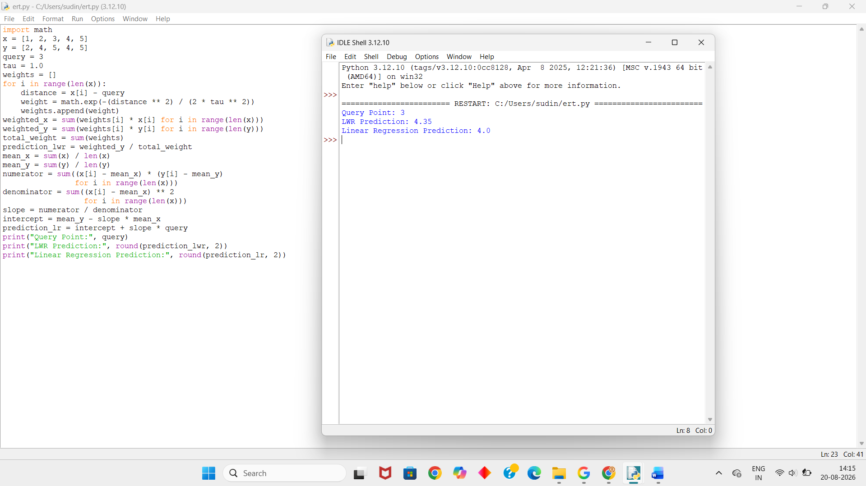

3. Write a Python program to implement a simple Radial Basis Function (RBF) network for regression or classification. Use Gaussian functions as activation units and train the model on a small dataset. Display predicted outputs and analyze how centers and widths affect performance.

Aim:
To implement a simple Radial Basis Function (RBF) network using Gaussian functions and predict the output for a given input.
Algorithm:
- Create a small training dataset.
- Select RBF centers from the training data.
- Calculate the distance between the input and each center.
- Apply the Gaussian function to calculate RBF activation.
- Combine the activations using weights.
- Predict the output.
- Display the predicted output.
- Analyze the effect of centers and width on the prediction.

Python Code:
import math
x = [1, 2, 3, 4, 5]
y = [1, 4, 9, 16, 25]
centers = [2, 4]
width = 1.0
def rbf(x, center):
return math.exp(-((x - center) ** 2) / (2 * width ** 2))
w1 = y[1]
w2 = y[3]
test = float(input("Enter test value: "))
a1 = rbf(test, centers[0])
a2 = rbf(test, centers[1])
prediction = (a1 * w1 + a2 * w2) / (a1 + a2)
print("Test Input:", test)
print("RBF Output 1:", round(a1, 3))
print("RBF Output 2:", round(a2, 3))
print("Predicted Output:", round(prediction, 2))
Output:
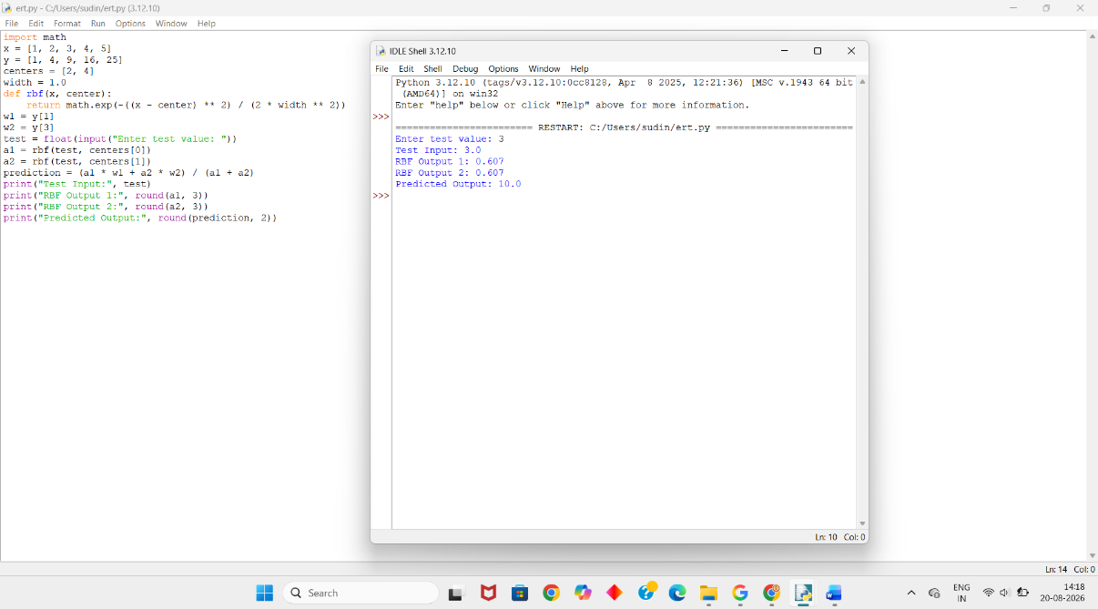

4. Create a Python program that implements a basic Case-Based Learning system. Store past cases in a dataset and retrieve the most similar case for a new query using distance measures. Output the solution based on the closest match and explain similarity calculation.

Aim:
To implement a simple Case-Based Learning (CBL) system that finds the most similar past case using Euclidean distance and provides its solution for a new query.
Algorithm:
- Store previous cases with their features and solutions.
- Accept a new query from the user.
- Calculate the Euclidean distance between the query and each stored case.
- Find the case with the smallest distance.
- Retrieve the solution of that case.
- Display the most similar case and its solution.
Python Code:
import math
cases = [
([2, 3], "Low Risk"),
([3, 4], "Low Risk"),
([7, 8], "High Risk"),
([8, 7], "High Risk")
]
x = float(input("Enter first value: "))
y = float(input("Enter second value: "))
query = [x, y]
smallest_distance = float("inf")
best_case = None
best_solution = None
for case, solution in cases:
distance = math.sqrt(
(query[0] - case[0]) ** 2 +
(query[1] - case[1]) ** 2
)
if distance < smallest_distance:
smallest_distance = distance
best_case = case
best_solution = solution
print("\nNew Query:", query)
print("Most Similar Case:", best_case)
print("Distance:", round(smallest_distance, 2))
print("Solution:", best_solution)
Output:
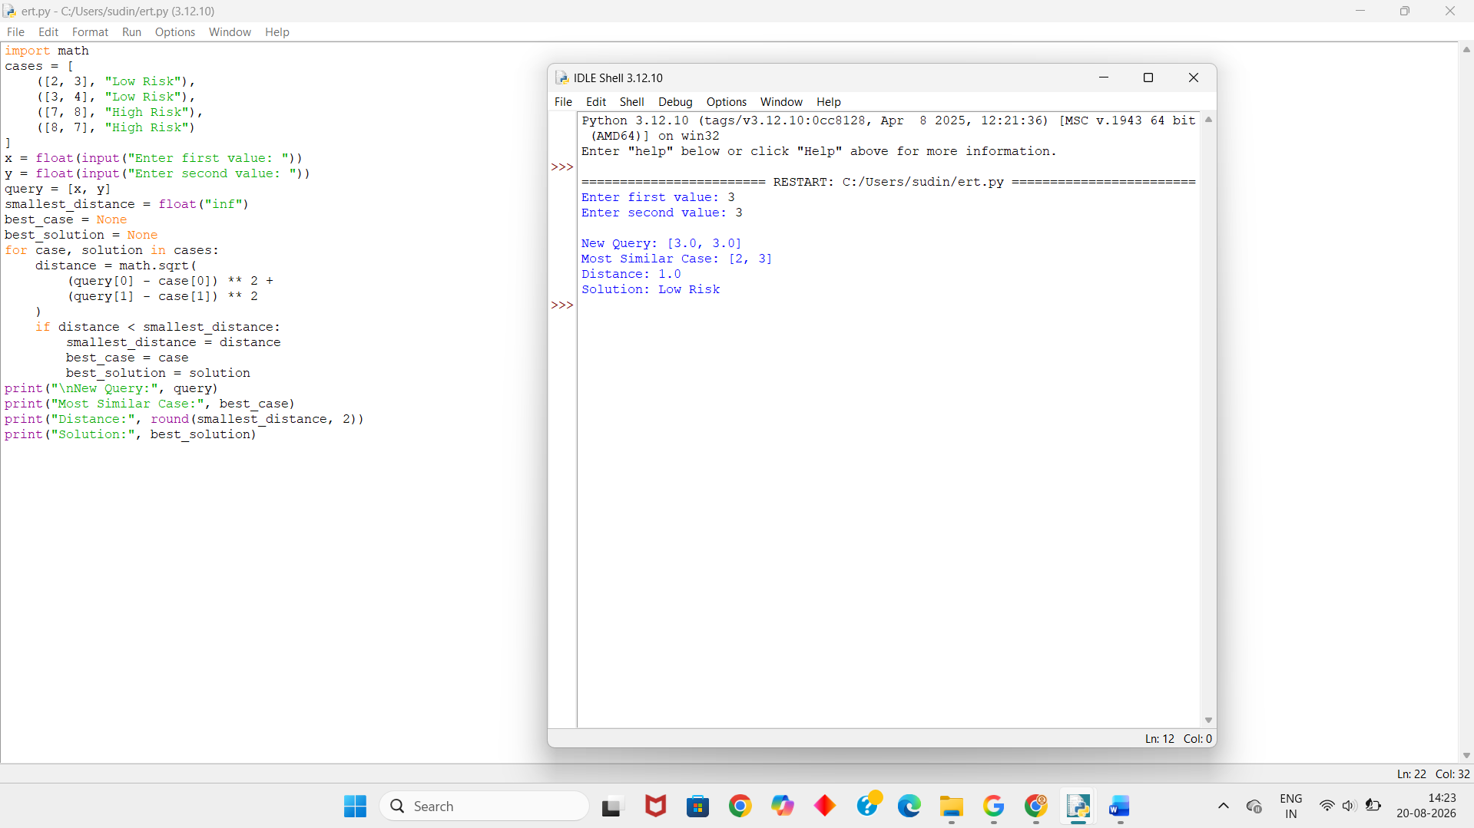

5. Write a Python program to implement both KNN and RBF models on the same dataset. Compare their predictions for given test inputs. Analyze differences in computation, accuracy, and output behavior, and display results clearly for better comparison.

Aim:
To implement K-Nearest Neighbour (KNN) and Radial Basis Function (RBF) models using the same dataset and compare their predictions and accuracy.
Algorithm:
- Create a small dataset with two classes.
- Divide the data into training and testing data.
- Implement KNN using Euclidean distance.
- Implement RBF using a Gaussian function.
- Predict the class of test data using both methods.
- Compare the predictions with actual classes.
- Calculate and display the accuracy of both models.
Python Code:
import math
X = [1, 2, 3, 7, 8, 9]
Y = ["A", "A", "A", "B", "B", "B"]
test = [2, 8]
actual = ["A", "B"]
def knn_predict(value, k=3):
distances = []
for i in range(len(X)):
distance = abs(X[i] - value)
distances.append((distance, Y[i]))
distances.sort()
nearest = distances[:k]
labels = [label for distance, label in nearest]
return max(set(labels), key=labels.count)
def rbf_predict(value):
centers = [2, 8]
classes = ["A", "B"]
width = 1.5
scores = []
for center in centers:
score = math.exp(
-((value - center) ** 2) / (2 * width ** 2)
)
scores.append(score)
return classes[scores.index(max(scores))]
knn_results = []
rbf_results = []
for value in test:
knn_results.append(knn_predict(value))
rbf_results.append(rbf_predict(value))
print("Value\tActual\tKNN\tRBF")
for i in range(len(test)):
print(test[i], "\t", actual[i], "\t",
knn_results[i], "\t", rbf_results[i])
knn_correct = sum(knn_results[i] == actual[i]
for i in range(len(actual)))
rbf_correct = sum(rbf_results[i] == actual[i]
for i in range(len(actual)))
knn_accuracy = knn_correct / len(actual) * 100
rbf_accuracy = rbf_correct / len(actual) * 100
print("\nKNN Accuracy:", knn_accuracy, "%")
print("RBF Accuracy:", rbf_accuracy, "%")

Output:
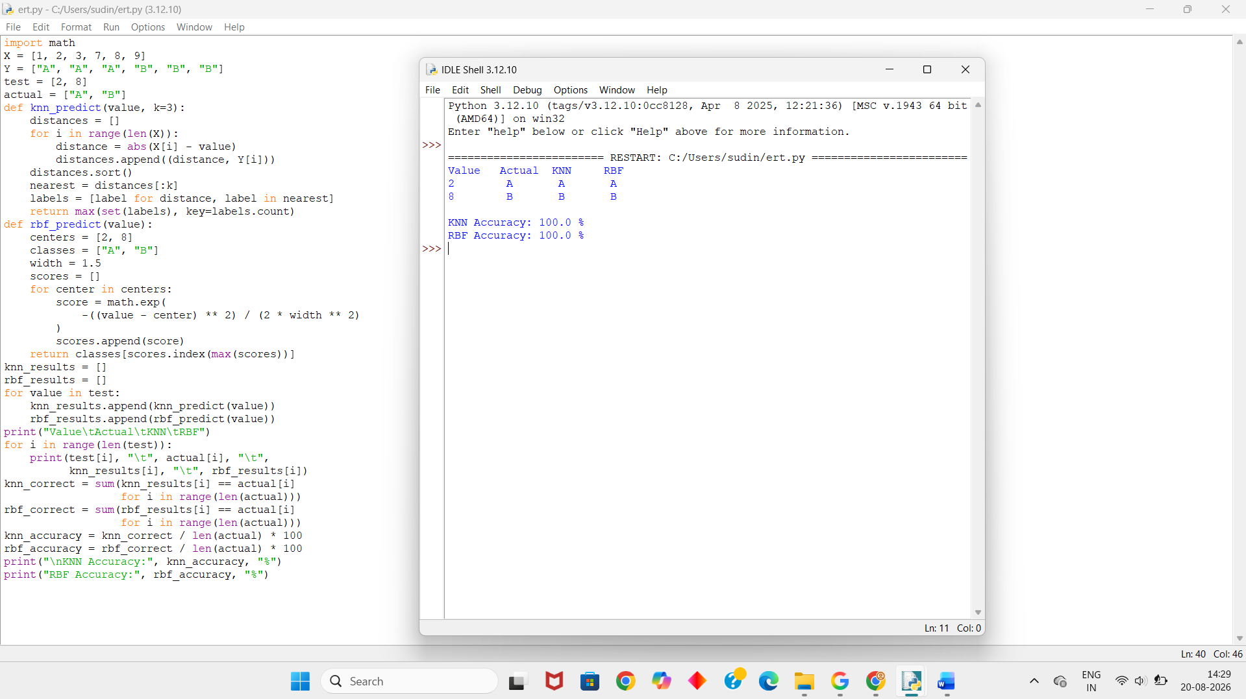

RUBRICS FOR CALCULATION

Criteria | Weightage | Level 4 – Exemplary (5 Marks) | Level 3 – Proficient (4 Marks) | Level 2 – Developing (2–3 Marks) | Level 1 – Beginning (0–1 Mark)
Conceptual Understanding | 30 | Demonstrates clear and complete understanding of the concept | Good understanding with minor gaps | Basic understanding with some misconceptions | Poor or incorrect understanding
Accuracy of Answer | 20 | Completely correct answer with no errors | Mostly correct with minor errors | Partially correct with noticeable errors | Incorrect or irrelevant answer
Application of Knowledge | 15 | Correctly applies concepts to solve the question/problem | Applies concepts with minor mistakes | Limited or partially correct application | No or incorrect application
Completeness of Response | 20 | Covers all required parts of the question | Covers most parts with minor omissions | Covers only some parts | Incomplete or missing response
Clarity & Presentation | 15 | Clear, concise, and well-organized answer | Understandable with minor issues | Somewhat unclear or poorly structured | Difficult to understand

